2019R2 AME installation
After importing and publishing AME customization, you should see:
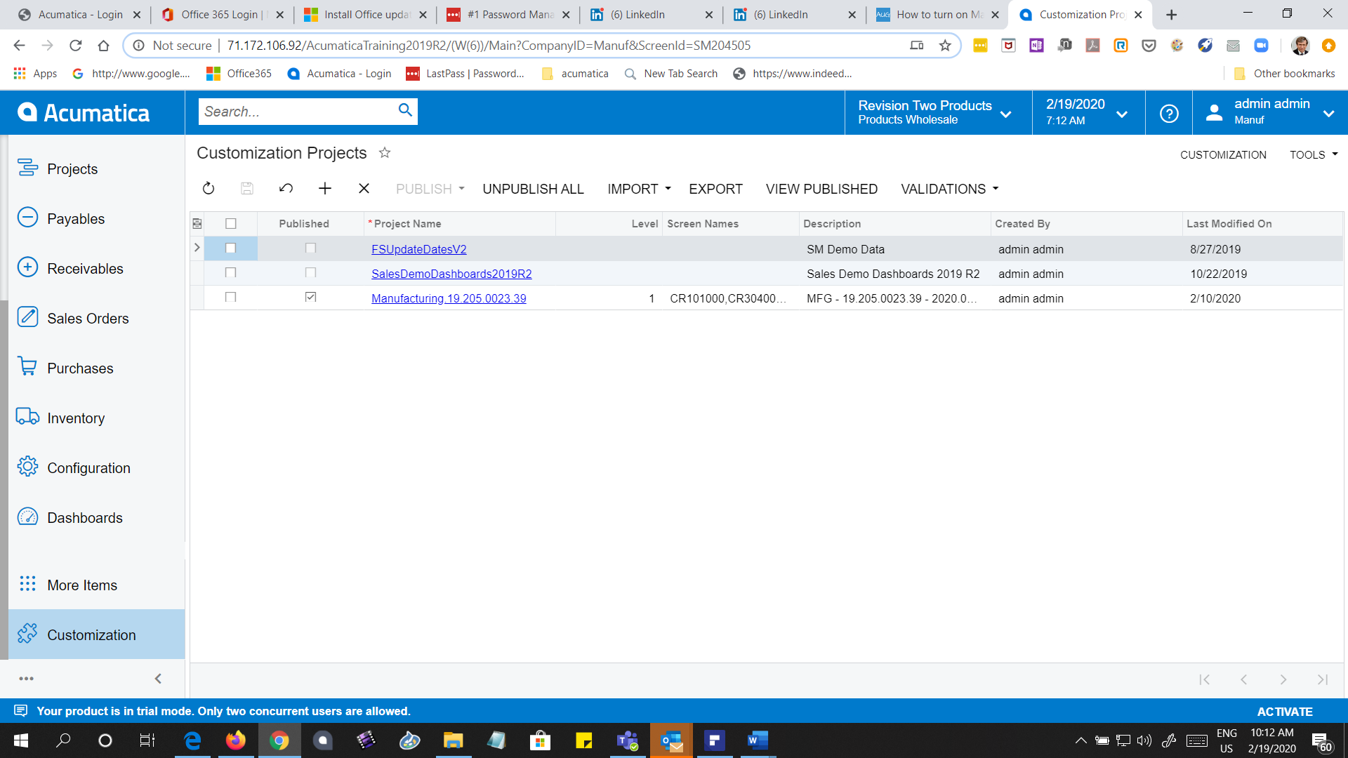
Do not import the wiki files help customization, since it creates an error.
Then enable the Manufacturing features
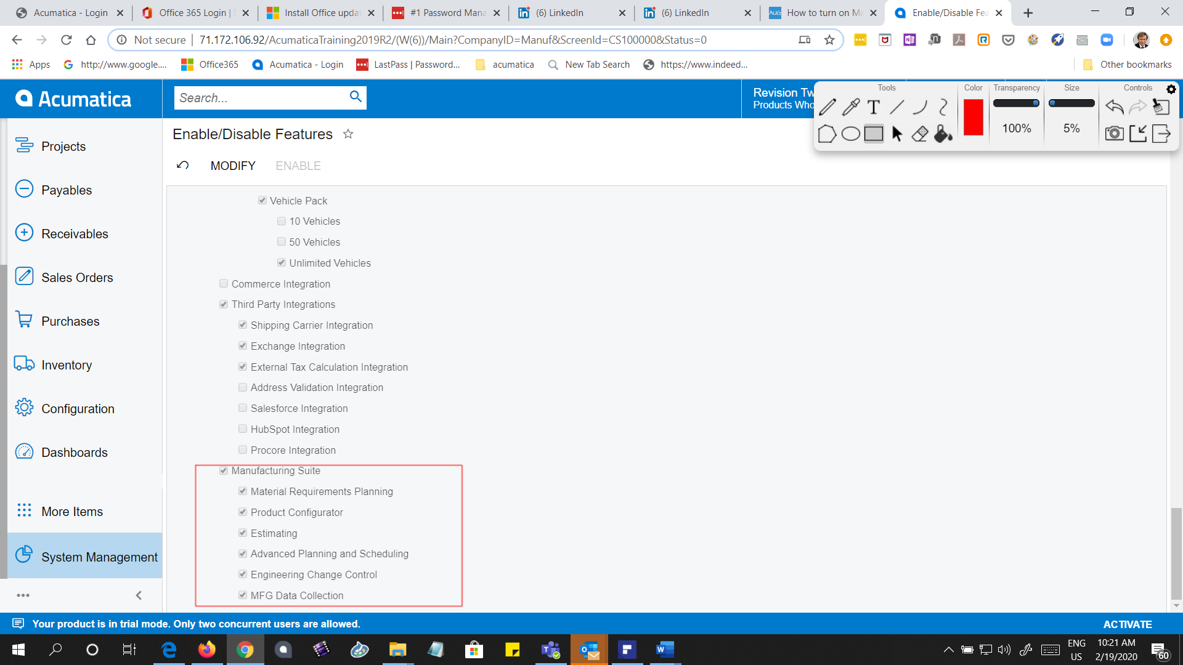

Toon Six
www.intercs.com
ToonSix@intercs.com

